

Procurement Plan Scope of Work Creation

Release Note

www.projectobjects.com

support@projectobjects.com

Table of Contents

Overview: 3

Data table for plant area: 3

Scope of Work page under standard codes: 3

User control for Scope of Work: 3

Changes in cost element creation: 4

## Overview:

In this release, we have developed the possibility to create a **“Scope of Work”** text using a function to text together. We have created a data table for **“Plant Area”**, user control for the **“Scope of Work”** text, **“Scope of Work”** page under standard codes, and implemented the filtering logic as per the requirement. We have also done the changes in the cost element description field.

## data table for plant area:

Here we have created a data table for **“Plant Area”** in business object configuration and make it customizable for the end-users. This data table is used in the **“Scope of Work”** page under standard code and also used in the **“Scope of Work”** pop-up.

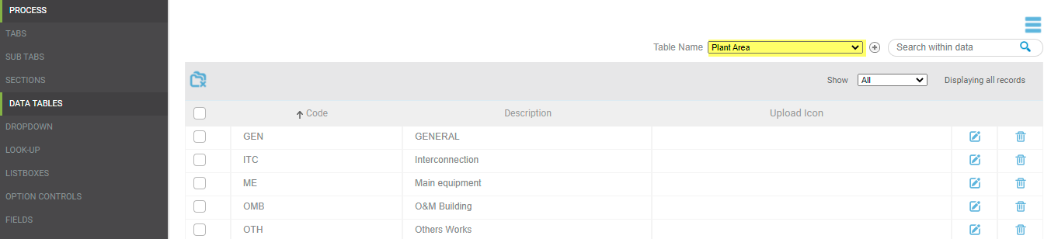

## Scope of Work page under standard codes:

Here we have developed a new page **“Scope of Work”** under standard codes. This page contains 3 columns **“Technology”**, **“Plant Area”** and **“SoW”**. Here user can add/edit/delete the list of SoW.

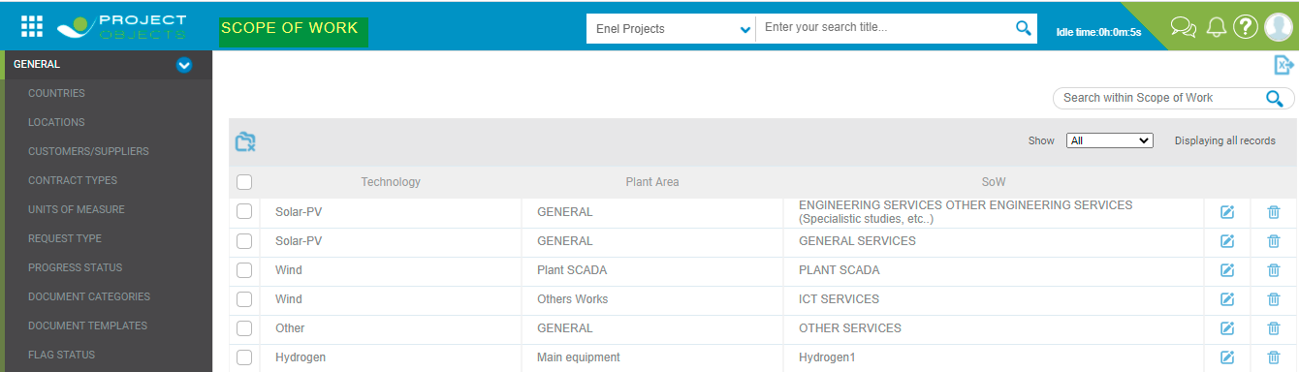

* **Technology**: This column contains a dropdown filled with **Technology** created under business object configuration (Technology data table).
* **Plant Area:** This column contains a dropdown filled with **Plant Area** created under business object configuration (Plant Area data table).
* **SoW:** This is the open textfor manual entry**.**

## User control for Scope of Work:

Here we have developed a new user control for **“Scope of Work”** which is used in the procurement plan form. This User control is a text box with an icon.

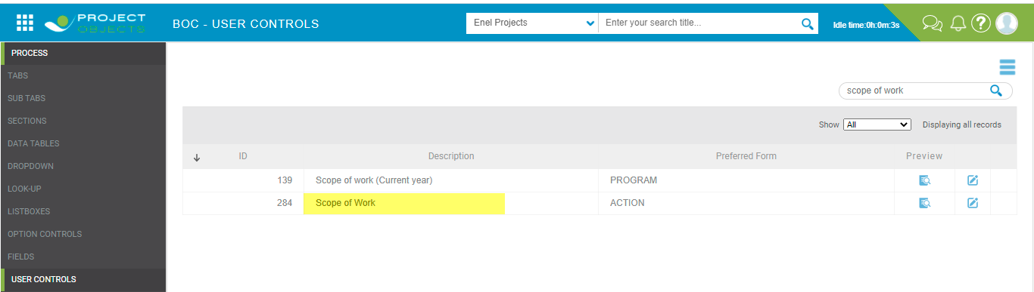

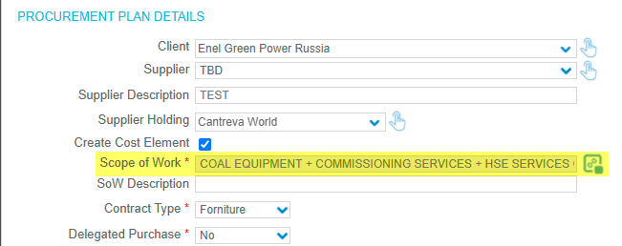

With one click of Icon, a pop-up will open with the columns **Technology, Plant Area**, **SoW**, and **Bind (Check Box)**. These columns will show the data user has created on the “**Scope of Work”** page under standard code.

We have implemented the real-time filters on columns and the list will be filtered as per the **Technology** selected in the project.

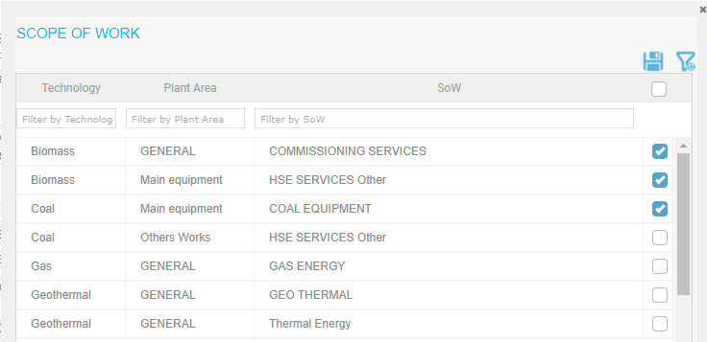

A new function will make a text by combining all the selected texts from the **SoW** columns (top to bottom order). And this text will be visible in the “**Scope of Work”** text box, this text box will be non-editable.

We have set Max. Length **200** for showing selected **SoW** in the text box. We have keep design aligned with other controls over the form. We have showed selected SoW on Tooltip of textbox.

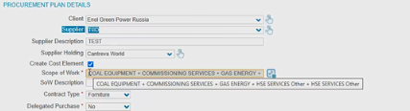

Here we have also given the possibility to the user to see the previous selection and modify the **“Scope of Work”** text. Once the **SOW** is created/saved, if the user clicks again on the Icon, the **SoW** Text Creation Popup will appear showing the previous selection and giving also the possibility to the user to change selections to modify the **SOW**.

## Changes in cost element creation:

As we are referring **SoW** value for cost Element description, Now with the new approach, the length of the cost element description will be 80 characters and we need to truncate text exceeding the length of 80 characters in the cost element description.

